PRIVATE FIRE SERVICE INSTALLATION PACKET

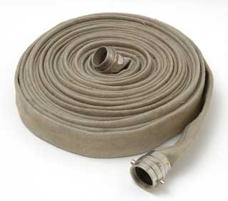

The 2013 Edition supersedes all previous versions for Private Fire Service Installation

To Whom It May Concern:

SUBJECT: PRIVATE FIRE SERVICE INSTALLATION

Illinois American Water (ILAW) looks forward to working with you and providing service to your private fire service. The enclosed informational packet has been prepared to guide you through the various components of the private fire service portion of your project. The step-by-step check list of requirements, discussion and forms included in this packet is an essential tool for planning your project and keeping it on schedule. Please carefully review and follow this guide. We cannot provide water service, even though the fire service connection may be completed, until all applicable requirements have been completed and submitted.

Please look over this packet carefully. Due to ILAW's desire for statewide uniformity of procedures, some changes have been made to our forms and to our internal operations. All documentation contained within this packet will be required, effective immediately. However, ILAW's representatives are committed to answering your questions and to make the paperwork process as easy as possible.

Included in the packet for your convenience is the checklist to help keep your project on track.

Please note that this packet is to be used only for the installation of a private fire service. If ownership of any new distribution main will be transferred to Illinois-American, the Developer Installed Water Main Booklet should be utilized. The definition of “Distribution Main” as approved by the Illinois Commerce Commission is, “water pipe owned, operated, or maintained by the Company which is used for the purpose of distribution of water, and to which service lines are connected.”

Very truly yours,

ILLINOIS AMERICAN WATER

INDEX PAGE NO.

Section One – Introduction of Document 3 - 5

Document Objective 3
General Considerations 3
Contact Details 4
Permissible Work by Contractor 5
Non-Permissible Work 5

Program Checklist 6 - 8

Section Two – Project Registrations and Project Design 9 - 11

Application for Private Fire Service 9
Design of Project 9

Section Three – Pre-Construction and Construction 12

Section Four – Project Acceptance 13

APPENDICES

Appendix AF Program Forms/ Contracts (in this book)

Appendix BF Cross Connection Control Program

Section One
Introduction of Document

This document provides an outline of the tasks and procedures to be followed by Owners during the installation of private fire services within the Illinois American Water System. This packet was developed with consideration to statutory, technical, financial and administrative issues that support and form the basis of an agreement between Illinois American Water and the Owner for the establishment of a private fire service.

1. Document Objective

This packet was established to provide the following:
- A clear, efficient and simple process to allow for private fire service installation.
- To ensure installation of the private fire service meets the Water Company requirements.
- To ensure that the private fires service is adequately designed and installed to protect the premise and protect the operation of the distribution system.
- To ensure that all water quality requirements are taken into consideration and achieved.
- Follows the procedures as outlined in the Illinois-American Water Company Rules, Regulations and Conditions of Water Service as approved by the Illinois Commerce Commission and effective June 1, 2009.

2. General Considerations

- Please consider bringing our involvement with your project as early as possible. It is never too early to talk with us regarding your proposed private fire service Working together and at the beginning of the project, the Water Company can support your team at every stage of design and assist you in saving time and money.
- The Water Company reserves the right to amend this packet and documents at any time without prior notice.
- Likewise, The Water Company reserves the right to reject submitted versions of the documents from this packet that have been substantially altered, in our opinion, without prior consent from the local Water Company Representative.
- Unauthorized operation of valves and hydrants within the existing distribution system is strictly forbidden. Water Company Representatives will operate all valves.
- The Water Company will not turn on the private fire service, even though the installation may be completed, until all applicable requirements have been completed and the documentation has been received and approved.
- This packet is intended to provide you with a point of contact that will be maintained throughout the project.

3. Contact Details
Chicago Metro and
South Beloit

Raymond Fowler
1000 International Parkway
Woodridge, Illinois 60517
Phone: 630-739-8819
Fax: 630.739.0477
Email: raymond.fowler@amwater.com

Note: If your fire service falls outside of the listed municipalities please contact the office closes to your development.

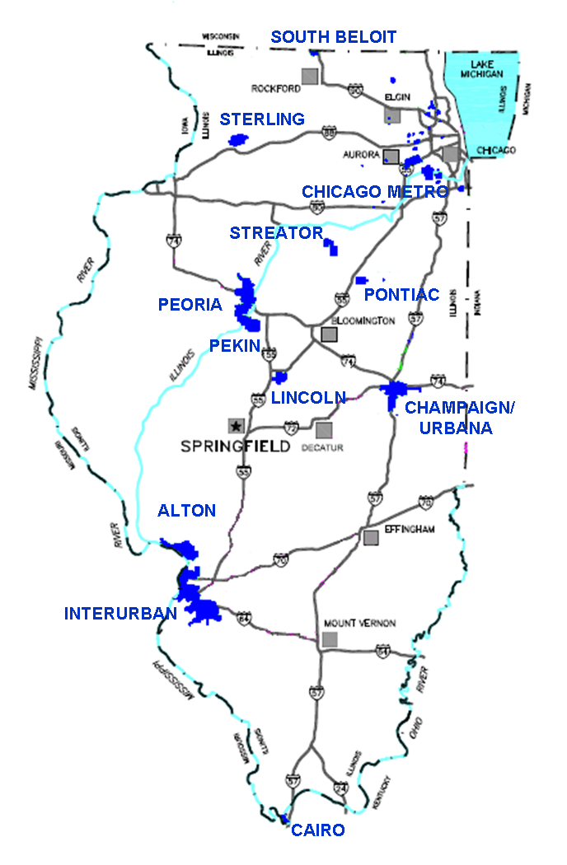

Peoria, Pekin , Sterling and Lincoln

James M. Ray
7500 N Harker Drive
Peoria, Illinois 61615
Phone: 309.566.4108
Fax: 309.689.3020
Email: James.Ray@amwater.com
Alton
Cairo
Metro East

Jeff G. Lampe
100 North Water Works Drive
Belleville, Illinois 62223
Phone: 618.239.3266
Fax: 618.277.7498
Email: Jeff.Lampe@amwater.com
Champaign/Urbana, Savoy, St. Joseph, Pontiac, & Steator
Jim M. Brown
1406 Cardinal Court
Urbana, IL 61801
Phone: 217.373.3271
Fax: 217.352.7008
Email: Jim.Brown@amwater.com

4. Required Work by the Developer/Owner

- Installing on-site fire service
- Installing on-site fire line meter or detector device (Company will provide and install the meter associated with the detector device).
- Installing on-site hydrants
- Designing on-site fire service in accordance with the appropriate rules and regulations.

5. Non-Permissible Work

- Connections or work that involves disruption to existing customers.
- Installing water meters.
- Operation of valves or hydrants off-site.
- Filling of private service or testing prior to acceptance of service by Water Company Representative.

PRIVATE FIRE SERVICE CHECKLIST
The following checklist is be used to insure that all items have been sent to ILAW for the acceptance of the Private Fire Service. This chart has a brief description of all tasks that are required by ILAW.

Project Registration and Design
(Following items need to be completed prior to Construction Agreement and Approval for Construction
Item No. | Form | Description | Initiated By | Date Submitted | Date Complete
1 |  | Water Company will provide to the Applicant the “Fire Service Installation Packet” outlining the requirements for this installation. | Water Company
2 | AF-1 | Applicant will provide to the Water Company a completed Project Application Form. | Applicant/  Engineer
3 |  | Water Company will provide fire flow information in the area of the proposed private fire service through the use of fire flow field tests and/or hydraulic model information. Water Company will determine the location of the new connection made to the Distribution Mains for the Private Fire Service. | Water Company
4 |  | Applicant will provide preliminary plans for the private fire service installation. The plans shall show the pipe, valves, sprinkler systems, hosing outlets, flow detector device, back flow prevention devises, hydrants and all connections, standpipes, tanks, pumps, openings and appurtenances contemplated in the application.  These plans shall be sealed by an Illinois licensed professional engineer or a National Institute for Certification in Engineering Technology (NICET) graduate who has attained a level III designation in fire protection engineering technology. | Applicant/  Engineer
5 | AF-2 | Applicant will provide to the Water Company a completed Data Request Sheet. The engineer or NICET graduate shall also provide a statement with supporting calculations based on fire flow test data that the proposed fire protection system includes a fail-safe cut-off switch or similar device which will not allow the pressure in the Company mains to be reduced below 20 psi at any time during the operation or testing of the fire protection system. The underlying data used to support these calculations shall also be provided to the Company. | Applicant/  Engineer
6 |  | Applicant will provide to the Water Company official notification from the applicable party, e.g. local Fire Department, which authorized the installation of fire service. In some communities, building permit office may be applicable. | Applicant/  Engineer
7 |  | Water Company will review Preliminary Plans and provide the Applicant with a Review Letter and/or precede the preparation of the Application for Private Fire Service Agreement. Allow at least 21 days for review and response to the initial Plan submittal. The actual initial review time may vary. | Water Company

Private Fire Service Agreement and Pre-Construction Approval
(Following items need to be completed prior to Approval for Construction)
Item No. | Form | Description | Initiated By | Date Submitted | Date Complete
8 | IF-3 | Water Company will prepare two (2) Applications for Private Fire Service Agreement and forward for execution. | Water Company
9 |  | Applicant will execute the application and return the application to the Water Company for final execution. Allow at least 10 days for the review of the documents | Applicant/  Engineer
10 | AF-3  CF 1 | Applicant will provide to the Water Company the name of the plumber and/or Sub Contractor installing the fire service from the main to the backflow preventer. Contractor will notify the Water Company at least 15 working days ahead of the intent to start work on site. Notification form can be faxed or electronically submitted. | Applicant/  Engineer
11 |  | Applicant will provide to the Water Company copies of applicable Right of Way construction permits. | Applicant/  Engineer
12 |  | Water Company will provide the Applicant with a letter and a copy of the completed and executed Private Fire Service Agreement. | Water  Company

Applicant CANNOT start private service connection installation without a copy of the plans that has been reviewed by a Water Company and acceptance of the Application for Private Water Service Agreement.

Post Construction and Pre-Acceptance
(Following items need to be completed prior to Acceptance of the Fire Service)
Item No. | Form | Description | Initiated By | Date Submitted | Date Complete
13 |  | The Water Company, the Contractor and the Engineer will make a final field inspection of the fire service connection, flow detector device and backflow preventer. Items not in accordance with the requirements of the Water Company will be outlined for completion by the Contractor. | All
14 | AF-4 | The Applicant’s Engineer or NICET Graduate will complete the Certification of Record Drawings and provide it to the Water Company. | Applicant/  Engineer

Acceptance
(Following items must be completed prior to allowing Service)
Item No. | Form | Description | Initiated By | Date Submitted | Date Complete
15 |  | Water Company will install the detector meter. | Water  Company
16 | AF-5 | Applicant will provide test results from Cross Connection Control Device Inspector (CCCDI). Form AF-5 can be used or similar form from CCCDI. Test results shall be sent to the ILAW Cross Connection Department as listed on form AF-5. | Applicant
17 |  | Service can now be provided. | Water Company

Section Two
Project Registration and Project Design

This section is intended to provide a general guideline for the registration of the proposed private fire service and an explanation of the information needed to allow for review of the application.

- Application for Private Fire Service

The Applicant shall submit an application form for a private fire service to the appropriate office as indicated in section one. Illinois American Water requests that this form be submitted at the earliest opportunity to allow for the company to determine if there is suitable water volume and pressure available in the Distribution Main abutting the Premises to be supplied by the service.

2. Design of Project

The Applicant’s Engineer shall be responsible for the design of the private water service. The Engineer shall utilize the specifications and information contained in this packet as a guide to information required by American Water. The overall design of the fire protection system and service will follow applicable local and federal requirements. The applicant will address the following issues and is subject to Illinois American Water approval prior to installation.

- Assessment of demand from the development, which will include
  - Fire flow requirements
  - Any other special water flow requirements
- Coordinate with Illinois American Water on the location of the appropriate point of connection for the fire service.
- Determination of adequate pipe size to address the required demand and maintain the minimum required level of service while maintaining appropriate pipe flow velocities.
- Determination of system configuration and layout.
- Engineer shall coordinate with Illinois American Water on the location of flow detector device and vault within the development. Device shall be located as close to the property line as possible. A detailed drawing of the vault shall be provided. If this location is not feasible than a suitable location shall be determine through the assistance with Illinois American Water.
- Engineer shall coordinate with Illinois American Water on the location of backflow prevention within the development. The device shall follow the Cross Connection Control Program as outlined in the Illinois-American Water Company Rules, Regulations and Conditions of Water Service as approved by the Illinois Commerce Commission and effective June 1, 2009. If the device can not conform to these rules than a suitable alternative shall be determine through the assistance with Illinois American Water.
- Backflow prevention device shall be located upstream of any Fire Department Connections (FDCs) and/or any private fire hydrants. Engineer shall coordinate with Illinois American Water on location to ensure proper protection is provided.
- Determination of how the system will be connected to the existing system with assistance of the water company to avoid outages to existing customers.
- Approval of fire hydrant locations by the appropriate fire authorities. Applicant must provide a letter of authorization from the appropriate fire department demonstrating that the requirements have been met for fire hydrant locations within the development and the Application (IF-3) must be signed by the appropriate fire department.

- In locations where approval of a fire service is required by the Local Fire Department the Applicant will execute the application with the approval of the department and return the Application to the Water Company for final execution. In locations where approval is not required then Illinois American requests that proof of notification of the Local Fire Department regarding the proposed fire service be provided and return the application to the Water Company for final execution

The water company’s standards and requirements are listed in Appendix B, C, D and E of the Developer Install Booklet.

The Applicant’s Engineer will provide three (3) sets of preliminary drawings for review by Illinois American Water. Plans should include all items outlined in the “TWELFTH” Condition listed in the Application. Submission of the drawings shall be by the three (3) sets of hard copy or electronically submitted as required by the representative of the company.

The drawings shall show the pipe, valves, sprinkler systems, hosing outlets, flow detector device, back flow prevention devises, hydrants and all connections, standpipes, tanks, pumps, openings and appurtenances contemplated in the application. The company will review the drawings based on the above criteria as well as to ensure that the water company’s standards and requirements have been met. The company will provide a letter outlining the deficiencies and requesting that the engineer address the deficiencies and resubmit three (3) revised sets of drawings.

The Applicant’s Engineer must be a Licensed Professional Engineer in the State of Illinois or a National Institute for Certification in Engineering Technology (NICET) graduate who has attained a level III designation in fire protection engineering technology.

- Maintain Minimum System Pressure – Hydraulic Calculations

Illinois American Water is required by the Illinois EPA to maintain a minimum 20 psi pressure in the distribution system. The engineer or NICET graduate shall also provide a statement with supporting calculations based on fire flow test data that the proposed fire protection system includes a low suction throttling valve or similar device which will not allow the pressure in the Company mains to be reduced below 20 psi at any time during the operation or testing of the fire protection system.

The throttling valve or similar device shall be pursuant to the NFPA 5.14.9.2 requirements

(2) Where the authority having jurisdiction requires positive pressure to be maintained on the suction piping, a pressure-sensing line for a low suction throttling valve, specifically listed for fire pump service, shall be permitted to be connected to the suction piping.

(3) Devices shall be permitted to be installed in the suction supply piping or stored water supply and arranged to activate a signal if the pump suction pressure or water level falls below a predetermined minimum, suction throttling valves or low pressure switches with alarms, may be provided to satisfy our requirement to maintain minimal pressures in the distribution system.

Illinois American will review the pump curves and supporting calculations to determine that proposed system will not impact the distribution system below 20 psi under normal conditions. In most cases, Illinois American Water will request that the control system incorporates a low pressure switch on the pump suction that will provide both a visual and audible alarm in the event that suction pressure is drawn down to 25 psi.

The underlying data used to support these calculations shall also be provided to the Company in the form AF4 and AF-4A.

- Cross Connection Control

The Applicant must design the private fire service so that it is furnished through a line guarded by an approved fire line meter or detector device and cross-connection control devices as required by the Illinois-American Water Company Rules, Regulations and Conditions of Water Service as approved by the Illinois Commerce Commission and effective June 1, 2009. These devices shall be furnished and installed by the customer at the Customer’s cost and expense.

For further clarification to the “EIGHTH” Condition listed in the Application, in order to receive written approval of introducing any chemical to any portion of the private protection system, a fixed air gap shall be provided as a backflow prevention in accordance with the Illinois Plumbing Code.

The Cross-Connection control device shall be located at a point approved by the Company and shall follow the Cross Connection Control Program included within this packet.

- Flow Detection Device

It is the intent of Illinois American Water Company to ensure that adequate fire flow is available to all customers throughout the distribution system. Illinois American is committed to designing and improving our infrastructure to provide water for legitimate fire fighting uses and periodic testing at no additional cost to the customers.

The detector check device provides Illinois American Water with better information on what is occurring in our distribution system so that we can better manage our systems and reduce risk to all customers. The detector check device allows us to register flow through a fire service that are usually associated with fire service leaks, unauthorized uses or other unusual events. With a more active look toward conserving and managing our water supply responsively, the detector check device allows us to obtain information from the approximately 15,000 fire services throughout our distribution systems in the state and allows us to ensure that we are not unknowingly losing treated water.

The detector check meter is a device for use on a fire service connection which consists of a check valve with a small metered bypass. The device works by measuring low flows which through the bypass meter that are insufficient to open the large check valve. The check valve opens for large flow rates associated with a fire event or testing and this flow is not measured.

The Applicant’s Engineer shall coordinate with Illinois American Water on the location of flow detector device and vault within the development. Device shall be located as close to the property line as possible to allow for detection of flow associated with fire service leaks in the future.

The device shall be located within a vault and be accessible. In addition, the device shall be constructed so that it can be isolated by two line valves to allow for future testing and maintenance. A detailed drawing of the vault and device shall be provided for review.

If this location is not feasible then a suitable location or alternative device shall be determined with the assistance of Illinois American Water.

Section Three
Pre – Construction and Construction

Through the proper design of the private fire service connection, it is anticipated that to a great extent the construction issues have been addressed. The water company expects that the Contractor shall utilize best practices for the installation of the service and follows the appropriate standards and specifications as included in the Developer Install Booklet.

The applicant shall submit to the Water Company the name of the fire service Contractor who will install all of the appurtenances from the Water Company main to the vault as listed in the “THIRD” and “FOURTH” Conditions of the Application. In areas where the contractor is allowed to install the tapping saddle and valve and make the connection to the distribution system, then the Contractor shall be selected from the prequalified list provided by the Water Company or otherwise approved by the Water Company in writing at the cost and expense of the Applicant.

At least 15 working days ahead of the contractor’s intention of starting work on the private fire service connection, the contractor shall submit form CF-1 “Notification of commencement of private fire service”.

Contractor will install the private fire service as per the approved plans and according to ILAWC Technical Specifications for Developer Installed Water Mains Booklet. No deviation from the approved plans and specifications shall be made without prior approval of Illinois American Water. Contractor shall ensure that components of the specified fire service devices are lead free. The water company reserves the right to request that the fire service connection be placed in an alternate alignment if the proposed changes will effect operation and maintenance of the network.

Section Four
Project Acceptance

Denial of any paperwork may result in services delayed by Illinois American Water to include, scheduling Final Inspections and even water service itself.

ILAW will channel inquiries and paperwork through the Engineering firm who should be the point of contact for all parties, unless alternative contacts are arranged.

Final Inspections should not be scheduled until the vault, flow detection device and the backflow preventer are complete and the finished grade established. If an inspection is scheduled and the weather turns bad or our crews must leave to handle a main break, ILAW will make every effort to work with you to reschedule.

If during the Final Inspection, it's discovered that repairs must be made to any part of the project, a list of those repairs will be submitted in writing to the Engineer. Repairs must be addressed in a timely manner and acknowledged in writing before ILAW will set the detector meter and establish the fire service.

And if at any stage of construction you have a question or concern, you are welcome to contact your local office so we may address the issue.

(page reserved for Contact Information for District)

